# Interferometer

## 1. Zero optical path difference (OPD)

Find the zero OPD position and plot the intensity profile as well as a surface plot for the destructive and the constructive interference cases (**4 plots**). Take care that you use **equal exposure** conditions for both states to show the contrast correctly.

Picture 1 – Destructive interference

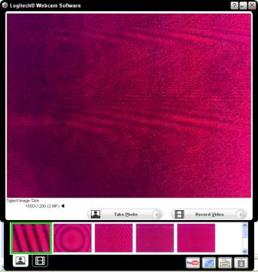

Picture 2 – Constructive interference

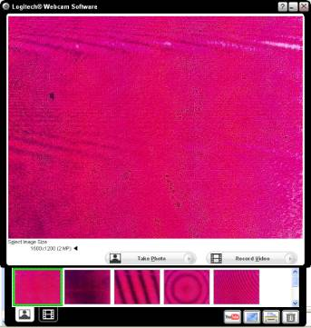

Graph 1 - Surface plot destructive interference

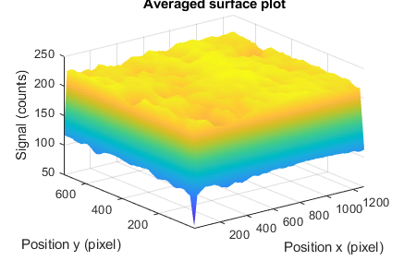

Graph 2 - Surface plot constructive interference



Explain why it is so difficult to align for the zero OPD.

What is the minimum OPD to go from a constructive to a destructive interference?

## 2. Measurement of laser fringe contrast

Show **three pictures** with different contrast and plot their line curve.







Measure the contrast as a function of position of the translation stage (over more than 1 full cycle of contrast variation, minimum 30 points, use the table below). **Step size 0.1 mm!**

|  |  |
| --- | --- |
| Relative position on the micrometer screw in mm | Contrast |
| 0 |  |
|  |  |
|  |  |
|  |  |
|  |  |
|  |  |
|  |  |
|  |  |
|  |  |
|  |  |
|  |  |
|  |  |
|  |  |
|  |  |
|  |  |
|  |  |
|  |  |
|  |  |
|  |  |
|  |  |
|  |  |
|  |  |
|  |  |
|  |  |
|  |  |
|  |  |
|  |  |
|  |  |
|  |  |
|  |  |

Plot the values (**one graph**).



Contrast versus mirror position. You should plot the position in mm.

You will now calculate the spectral width of the source using the period of the variation. (Eq. 12, where z is the period found in your measurement). **You must estimate the error on your measurement** knowing that the spectral width is expressed as



To do so, one needs to evaluate the error z on the peak distance from your contrast measurement plot that you have obtained above.

z =….

**Explain** how you have obtained this value.

Explanation: ………….

You also have to find the error on the wavelength:  = …..

This is **not** the spectral width! It is the wavelength uncertainty from the datasheet.

Now, using z and  find the **analytical** expression for the error on the spectral width 

  

Finally, the spectral is:  …..  ± ……  =

Explain why the contrast exhibits such a modulation versus the mirror position.

## 3. WEB - Example

Find an example of an application where interferometry is the key technique. Print a picture; give a **short explanation** and parameters that are measured. Cite correctly.

**(Optional) Personal feedback:**

Was the amount of work adequate?

What is difficult to understand?

What did you like about it?

How can we do better?